Resume

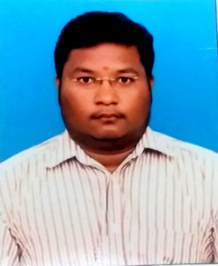

S. Jothinarayanan

#15 A, Somasundara Puram

Bhavani – 638 301, Erode (Dt.) Mobile : +91 99444 32432

Tamil Nadu. India. E-Mail : as.jothinarayanan@gmail.com

_________________________________________________________________ ___________________

OBJECTIVE :

I can effectively contribute my skill and full potential as well as for the welfare and development of the organization.

EDUCATIONAL QUALIFICATION :

* Graduation (B.com) from Bharathiar University, coimbatore in 2008 - 65 %
* 12th from HSC, State Board, karur in 2005 – 85 %
* 10th from SSLC, Matric, karur in 2003 – 68 %

ACCOUNTING SOFTWARE SKILLS :

* Tally 9.ERP
* Winman Software for Income Tax filing & Win-TDS for TDS filing

WORKING EXPERIENCE :

* Completed my CA Articleship Training at CA R. Sugumaran & co, Coimbatore.
* Worked in an auditor office from January 2009 to October 2015.
* Currently working in a private limited company as Finance Manager from November 2015 to till date

CURRENT WORK PROFILE :

* Finalization of Accounts, preparing Final Accounts like Trading, Profit & Loss account and Balance Sheet.
* Preparing Bank projection, CMA Data and Cash Flow Statement.
* Attending the Hearing of Sales Tax & Service Tax Dispute.
* Online filing & payment of Sales Tax, Service Tax, Central Excise, Income Tax & TDS .
* Follow ups of form from sales tax department. Download online C form from sales tax website and upload customer’s C form to the sales tax department.
* Preparing Bank Reconciliation Statement.
* Handling GST work.

COMPUTER SKILL :

* Know MS Office – Word, Excel & Power Point.

STRENGTH :

* Patience
* Flexibility
* Ability to learn new things.

PERSONAL DETAILS :

* Father’s Name : A.Srinivasan (Late)
* DOB : 16th Feb. 1988
* Sex : Male
* Marital Status : Married
* Nationality : Indian
* Region : Hindu
* Language Known : Tamil & English

PERMANENT ADDRESS :

15A, Somasundarapuram

Bhavani – 638 301.

Erode District.

DECLARATION :

All the information provided by me above is true & correct as per my knowledge and belief.

Date:

Place: Bhavani Signature